## 1. Install the phpMyAdmin Package

SSH to your Ubuntu server and update the package repository index.

$ sudo apt update -y

Make sure your system has the following required PHP extensions.

$ sudo apt install -y php-json php-mbstring php-zip php-gd php-curl

Install the phpmyadmin package.

$ sudo apt install -y phpmyadmin

When prompted to choose a web server, hit TAB, then ENTER to select apache2 as shown in the screenshot below.

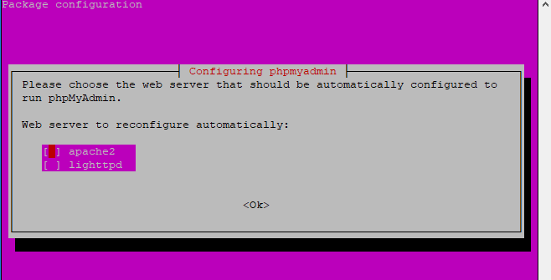

When prompted to configure a database for your phpMyAdmin package, choose Yes and press ENTER to proceed.

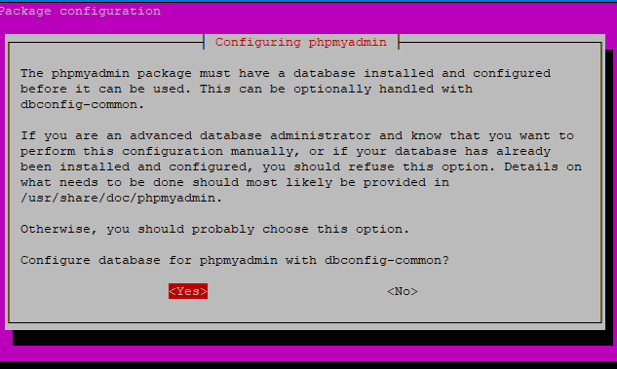

Enter a strong password for the phpMyAdmin package. Press TAB and ENTER to proceed.

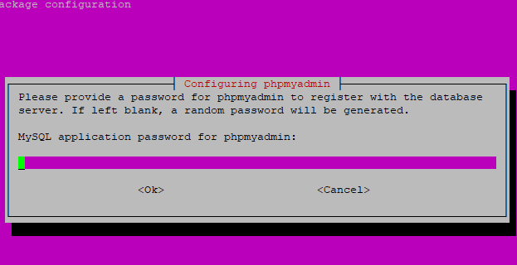

Repeat the same password to finalize the installation process. Press TAB and ENTER to continue.

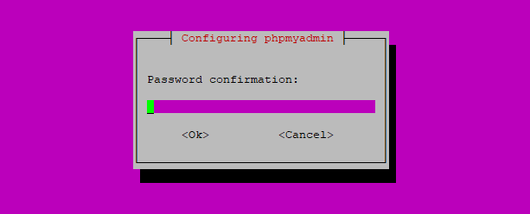

Use the a2enconf command to enable the new configuration file created by the phpMyAdmin.

$ sudo ln -s /etc/phpmyadmin/apache.conf /etc/apache2/conf-available/phpmyadmin.conf

$ sudo a2enconf phpmyadmin.conf

Restart Apache to load the new configuration file.

$ sudo systemctl restart apache2

With the phpMyAdmin package installed, you'll create a sample database and a user next to demonstrate the login process via a web browser.

## 2. Set up a Sample Database and User

Log in to your MySQL server as root via the command-line interface.

$ sudo mysql -u root -p

Enter your MySQL root password and press ENTER to proceed.

Create a sample_db database.

mysql> CREATE database sample_db;

Create a test_user for the sample_db and exit from the command-line interface. Use the command for your database engine, either MySQL or MariaDB.

* MySQL.

  
mysql> CREATE USER 'test_user'@'localhost' IDENTIFIED WITH mysql_native_password BY 'EXAMPLE_PASSWORD';

mysql> GRANT ALL PRIVILEGES ON sample_db.* TO 'test_user'@'localhost';

mysql> FLUSH PRIVILEGES;

mysql> QUIT;

*   
  MariaDB.

  
MariaDB> GRANT ALL PRIVILEGES on sample_db.* TO 'test_user'@'localhost' identified by 'EXAMPLE_PASSWORD';

MariaDB> QUIT;

Navigate to the URL below in a web browser to test the installation. Replace 192.0.2.1 with the correct domain name or public IP address of your server.

http://192.0.2.1/phpmyadmin

Then enter the credentials of the test_user you've just created to log in.

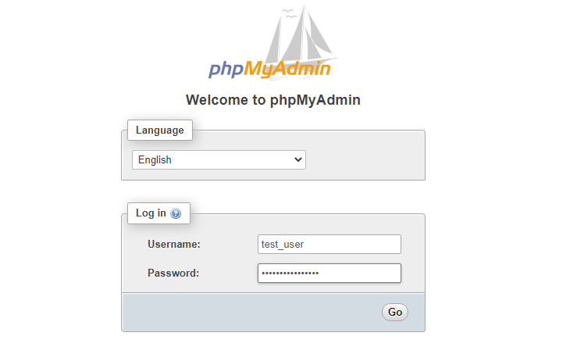

You should now see the phpMyAdmin dashboard as shown below. As you can see, the sample_db is now among the list of databases that you can access.

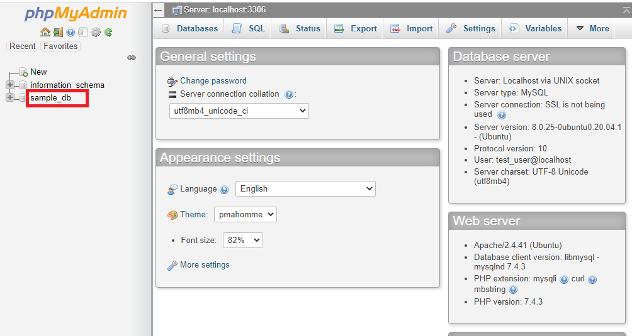

Your phpMyAdmin software is now in place. In the next step, you'll harden its security using Apache basic authentication.